
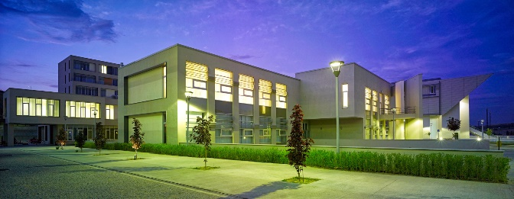
PARTNER UNIVERSITY DATASHEET

1. GENERAL INFORMATION
Name of University | CANKAYA UNIVERSITY
Erasmus Code – EUC Number | TR-ANKARA08
Address ( Postal ) | Cankaya University, Ankara  International Relations & Erasmus Office
Fax | +90 312 2331028
E-mail | iro@cankaya.edu.tr  yontem@cankaya.edu.tr
Institutional Erasmus Coordinator | Yontem OSKIPER

DON’T FORGET TO CHECK THE ERASMUS WEBSITE
 http://iro.cankaya.edu.tr/
2. ACADEMIC INFORMATION
To reach the academic calender click the link below
UNDERGRADUATE ACADEMIC CALENDAR
Final Examination Periods
1st term: From 06-19 January 2025
2nd term: From 26.05.2025-15.06.2025

Recommended Arrival Dates (probable dates)
1st term: 20 September 2025
2nd term: 07 February 2025

Language of Courses: English
Link to course catalogue index:
http://www.cankaya.edu.tr/dersler/index_en.php

Buddy Program
All incoming exchange students are offered the possibility of benefiting from the so‐called CANKAYA UNIVERSITY Buddy Program that connects international students with Turkish student volunteers in order for them to be able to receive support, orientation and help during their first days at CANKAYA

3. EXCHANGE RELATED INFORMATION 4. TRANSPORTATION INFORMATION
Orientation Session for Incoming Students
1st term: The students will be informed after arriving.
2nd term: The students will be informed after arriving.

Language / Certificates requirements
Compulsory Not requested

Recommended Level B2 (English)

University Address: Eskişehir Yolu 29. Km, Yukarıyurtçu Mahallesi, Mimar Sinan Caddesi No:4, 06790 Etimesgut/ANKARA, Turkey
Nearest Airport: Esenboğa Airport
Getting from the Airport to the City Center:
You can reach the city center via bus from Esenboğa Airport: Esenboga Transportation Information
Bus transportation in Ankara is operated by EGO. You can use an Ankarakart, which can be purchased at newspaper kiosks, EGO booths, and metro stations. Tickets are not sold directly on the buses.
Transportation to the University:
The university provides free shuttle buses to campus. You can find the bus stops and schedules on the official website: University Shuttle Service

MOBILITY INTERNATIONAL OFFICE CONTACTS
Director Of International  Relations  & Erasmus Office | Mr. Yontem OSKIPER  TEL: +90 312 2331291  Fax : +90 312 2331028  E-Mail: yontem@cankaya.edu.tr
Bilateral Agreements | E-Mail: yontem@cankaya.edu.tr
Erasmus Students Mobility  (LLP – SMS) | Yontem Oskiper  E-mail: iro@cankaya.edu.tr
Erasmus Teaching/Staff  Mobility(LLP – STA – STT) | E-Mail: yontem@cankaya.edu.tr
Non-Erasmus Students Mobility | Yontem Oskiper  E-Mail: yontem@cankaya.edu.tr
Website For Incoming Students | http://erasmus.cankaya.edu.tr/en/course.php?page=14
E-mail for nominations / website for applications | iro@cankaya.edu.tr
Nominations / applications | 1st term : 15th July  2nd term : 15th December
General e-mail for enquiries | iro@cankaya.edu.tr

